Request for Support for Quarterly Grant Invoice and Expense Report
These instructions detail how to prepare and submit supporting documentation for a quarterly grant invoice and expense report. For accountability purposes, we want to assure that expenses billed comply with the grant budget and are supported by accounting records. This process is authorized by the grant contract, section II, final paragraph, as well as section III, paragraph D.
Please provide a schedule-- clear electronic or paper documentation path-- that shows us how you created the Children’s Levy expense report. We expect that all of you are already using an Excel workbook to figure out what costs from your accounting system general ledger go into the PCL expense report. So long as your process is easy to interpret and includes all the detail we need, you may be able to send it to us without modifying it. If actual expenses potentially applicable to your PCL grant exceed the amounts for which reimbursement was requested, provide documentation for actual expenses and indicate in the schedule where the billed amount was less than the actual expenses.
Instructions for Documentation
Supporting documentation should include:
For Personnel Expenses
- A list or schedule of expenses in Excel for each person for whom you are billing. The schedule will show general ledger detail and totals. The totals from the schedule should agree in amount to the amount billed for that position in the expense report.
  - The detail for each position should include the specific expenses recorded in your accounting system with positions, names, dates & amounts.
  - Since grant budgets identify positions, rather than individuals, it is important that the schedule name both the position and the individual occupying the budgeted position. That way, we can see that the charges conform to the budget.
  - If you only charge a portion of a person’s time to PCL, please clearly label the calculation in the schedule. In general, when you use an allocation method for any cost, please make it clear what that method is in the Excel document you submit.
- General ledger detail reports or payroll records that support the amounts shown in the schedule. You may redact (black out) any personal information that PCL does not need for the purpose of this accounting requirement.
For Contractors
- A list or schedule of detailed expenses for each contractor for whom you are billing with totals that agree in amount to the amount billed for that contractor in the expense report
- Again, if there is any allocating of costs, please show the method and calculations.
- General ledger detail or Invoice receipt records that support the amounts shown in item #1.
For Program Expenses
- A list or schedule of expenses for each line item for which you are billing with totals that agree in amount to the amount billed in the expense report.
- General ledger detail reports or Invoice receipt records that support the amounts shown in item #1.
- Often program expenses are allocated from a larger pool of expenses. In these cases, please show the allocation method in the schedule.
For Data/Evaluation
- A list or schedule of expenses for each line item for which you are billing with totals that agree in amount to the amount billed in the expense report.
- If personnel expenses are included in Evaluation, please submit the information similarly to how you submitted it for Personnel Expenses above.
- General ledger detail reports or Invoice receipt records that support the amounts shown in item #1.
Administrative Expenses
Since administrative expenses are typically based on an administrative rate, no further detail is needed for this category.
Submission Instructions
Please submit schedules as Excel file(s), ideally with multiple tabs. General ledger reports and receipts should be submitted as PDF files. See below for an example of an Excel file submission.
It is critical that electronic submissions come to us in an order that is easily reviewed. We are not requiring a standard format, but if it is difficult to review, we will ask you to revise and resubmit. The order and organization of the documents submitted should be easy to open and review.
If you prefer, you could mail paper copies of the supporting schedules and receipts. If you choose this method, please be sure that the pages are in an order that is easily reviewed. For example, a schedule of personnel expenses followed by payroll records in the same order as the items on the schedule.
Incomplete Supporting Documentation
If any expenses are not supported by general ledger detail, receipts or other evidence of payments, PCL staff may seek to remedy the situation by the methods written in the grant contract, section III, paragraph B, as well as section IV, paragraphs A-E.

If you have questions about this process, please contact John Kelly at john.kelly@portlandoregon.gov or call at 503.823.2980.

Example of Excel Schedule
We created an Excel file with examples of what the schedule might look like and included it with the email transmitting these instructions. It has 3 tabs for 3 of the PCL grant budget categories. Our explanations appear in red. Again, this is not a required format, but is meant to give you an idea of how the schedule might be done.
The following are excerpts from the example excel file:
This example would be on a Personnel Tab in the Excel Schedule. Items in red are our explanation and would not appear in your file.
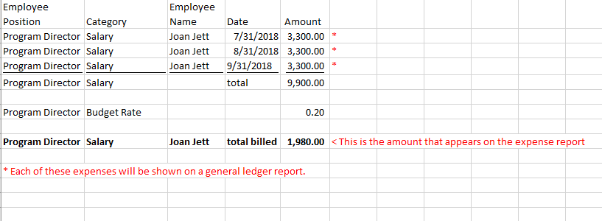

This example would be on a Program Expense Tab in the Excel Schedule. Items in red are our explanation and would not appear in your file.
